Title

- Abstract

- Introduction
[This section should motivate the importance of the research problem, give an overview of your approach to solving the problem, and explain why it is a novel and valuable contribution. Introduction sections for ML conferences often end with a bulleted list of the specific contributions of the paper (both methodological and applied/impact).]

Understanding racial disparities in political behaviour is an essential component of modern social science,unfortunately researchers frequently encounter challenges because many administrative datasets do not include clear information about race. Voter files, credit datasets, consumer data, and hiring records frequently omit race, yet researchers and practitioners still require race estimates to assess fairness, detect disparate impact, or quantify group-level behavioural patterns. To overcome this limitation, researchers increasingly rely on methods such as Bayesian Improved Surname Geocoding (BISG) introduced by Elliott et al. (2009)[1]. BISG is a probabilistic method that infers race using surnames and geographic information. By applying Bayes’ Rule, BISG produces a posterior probability vector representing the likelihood that an individual belongs to each racial group

Once these race probabilities have been produced by BISG, researchers then need to choose a method to convert those probabilities into a race label that can be used for further processing. Over the years, the following are the two strategies that have been used most commonly:

- Threshold-based BISG assignment:
In this method, individuals are assigned to a race category if their BISG probability for that category exceeds a predetermined cutoff or threshold value. Threshold selection is mostly picked by experiment and checking how sensitive the results are, instead of just using a standard cutoff value. Recent work on demographic inference and fairness recommends using thresholds in the 0.60–0.80 range to balance racial classification precision against sample retention[2]. Lower thresholds retain more individuals but increase the likelihood of incorrect assignments, whereas higher thresholds produce cleaner race labels at the cost of excluding ambiguous cases and potentially introducing selection bias into downstream analyses. Fairness-focused studies also emphasize that threshold choices can meaningfully reshape measured disparities and must therefore be justified and reported transparently making it essential to clearly explain and validate the chosen threshold.
- Weighing-based BISG assignment:
In probability-weighted BISG, individuals are not assigned to a single race. Instead, they contribute to all racial groups based on their predicted probabilities. For example, a person might count as 0.6 White, 0.3 Black, and 0.1 Asian. This approach keeps the uncertainty from the BISG predictions and reduces errors that can happen when forcing everyone into one category. It has been used in real-world settings like clinical trial recruitment, where probabilistic race estimates help create more diverse and balanced participant groups without losing too many people from the sample[3]. The main advantage is that it gives more accurate and stable estimates of group-level differences. The main drawback is that it is more complicated to analyze, because many fairness metrics expect each person to belong to only one group. Still, using probability-weighted BISG helps capture uncertainty and avoids some of the problems caused by hard assignments.
In this study, using the North Carolina voter dataset, we first compute race using BISG and then use machine learning to predict party affiliation. We compare how disparities appear across the ground-truth race labels, threshold-assigned BISG race, and probability-weighted BISG race. This comparison helps show how different BISG race assignment methods affect fairness assessments and predicted outcomes, highlighting the trade-offs between simplicity, accuracy, and uncertainty in race inference.

- Related Work
[This section should describe the most closely related prior literature and why your work is different/better.]

A popular technique for determining race and ethnicity in datasets lacking self-reported race is Bayesian Improved Surname Geocoding (BISG). BISG generates posterior probabilities for each racial group by combining geographic demographic data with surname information. BISG can achieve high predictive accuracy, especially in administrative datasets like voter files or health records, according to validation studies [4], [5]. In their evaluation of BISG in transportation research, Sartin et al. [4] discovered that it was useful for examining racial disparities in situations where race data was not readily available. In order to reduce misclassification in subsequent analyses, Greengard and Gelman [6] proposed a calibrated BISG that enhances the alignment of predicted probabilities with actual population distributions.

Converting the probabilistic outputs into useful race labels is a major challenge when using BISG. A person is assigned to a race group by threshold-based BISG if their posterior probability is higher than a predetermined cutoff. Usually in the 0.60–0.80 range, thresholds are empirically determined to balance sample retention and misclassification [4], [6]. Even though thresholding makes analyses easier, misclassification can still have an impact on disparity estimates, particularly in smaller groups [7].

Each person's complete posterior probability vector is preserved by probability-weighted or soft BISG, enabling them to make fractional contributions to all racial groups. This approach maintains uncertainty in subsequent analyses and minimizes errors caused by classifying people into a single category. Craig et al. [7] showed its usefulness in clinical trial recruitment, assisting in balancing cohorts without sacrificing sample size, while Badrinarayanan et al. [8] used this method in privacy-preserving race estimation for fairness measurement. Soft BISG yields more stable and nuanced group-level estimates, but it is more analytically complex because many fairness metrics assume discrete group membership.

Finally, several studies have examined the implications of BISG for fairness and bias in predictive modeling. Misclassification in inferred race can distort fairness metrics, and thresholding versus weighted approaches can lead to different conclusions about disparities [9], [3]. These works highlight the need for transparency, careful threshold selection, and consideration of uncertainty when using BISG in social and political science research.

- Methods
[This section should describe your methodological approach in detail. (Often, the novel contribution of the paper is methodological, and is described here.)]

The paper aims to compare two methods for using BISG probabilities to determine disparity with the true disparity obtained from the true race code. After obtaining the BISG probabilities, we can either convert them into a single race code or use them directly in the disparity calculation.

True Disparity

For calculating true disparity, we ask ‘How much does party affiliation differ between groups A and B when we use their real race labels?’. Thus, we calculated true disparity as the difference between the average outcomes of two racial groups when using the observed race values.

Given that Y denotes 0 and 1 of belonging to a particular party.

Thresholding Estimator

Thresholding involves using a hard classification line, where a threshold is set and used to determine the race for each record in the dataset. We set the threshold at value q. If the maximum probability in the list of probabilities exceeds q, we assign that probability to the race. Otherwise, we leave it unclassified.

We calculate the disparity as follows, where Aq is the race label obtained after thresholding.

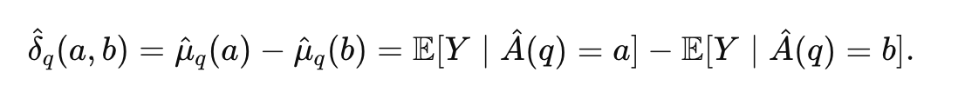

Weighing Estimator

When using weighing, we consider the fractional race memberships. It is not a single race label assigned to a record, instead, each race contributes an amount equal to its probability to the disparity. The method of weighing we discuss here is from [21].

To calculate the disparity when using the weighing estimator, we first compute the weighted average of each race's outcomes. We multiply the probability of belonging to a particular race class u by the outcome (0/1) of belonging to a specific party, then divide by the total weight of race u in the dataset.

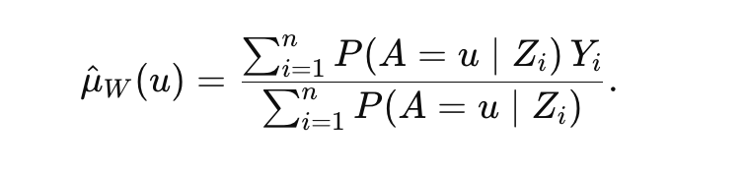

After we calculate the weighted averages of each race's outcomes, we can compare the two races as follows.

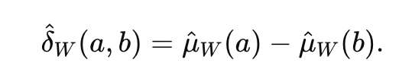

- Evaluation
[How did you evaluate your methodological approach? Describe the datasets you used, evaluation metrics used to measure performance, other methods you compared to.]

We used the North Carolina Voter Registration Data. The dataset contained 8,546,645 records. After removing records with invalid names and no zip code, we had 7,601,970 records. As we did not have the capacity to process such a large dataset, we sampled it by race and party for this experiment, working with only 760,196 records.

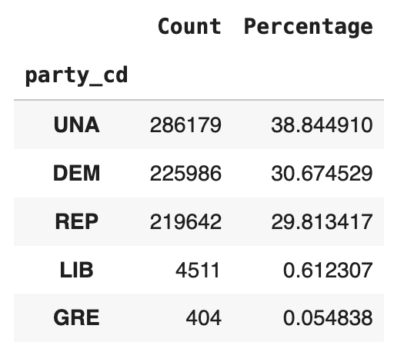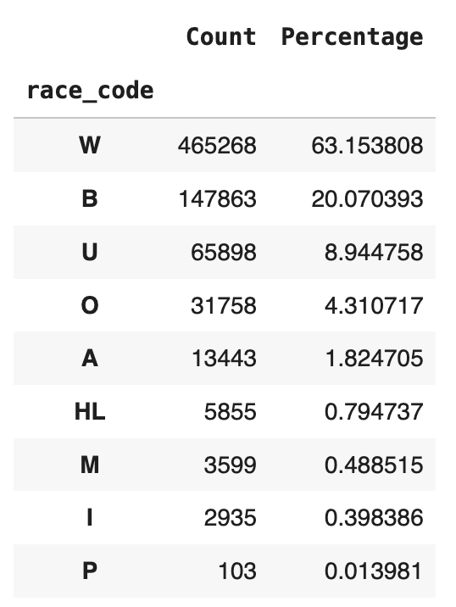

We used the Python library Pyethnicity for calculating BIFSG. The function returns a dataframe containing the probability that each record belongs to white, black, Asian, or Hispanic groups. The BIFSG function in Pyethnicity requires the geographical location to be provided in ZCTA format. ZCTAs (Zip Code Tabulation Areas) were created by the U.S. Census Bureau to aid statistical measurement[10] and differ from zip codes. Since our dataset consisted of ZIP codes, we used a ZIP Code to ZCTA Crosswalk file that maps ZIP codes to ZCTAs. After obtaining the ZCTA values, we used the BIFSG function and computed the race probabilities.
We then removed all race information and race probabilities, and trained a Random Forest Classifier to predict to which party each record would belong. After we obtained the prediction, we ran our disparity checks on it to determine how the disparity measured by thresholding and weighing compared with the true disparity obtained from the observed race.

- Results
[Describe the results of the evaluation here. Tables and figures showing the results are common in this section.]

The true race codes and the race counts after performing thresholding on the race probabilities are found in table <> .
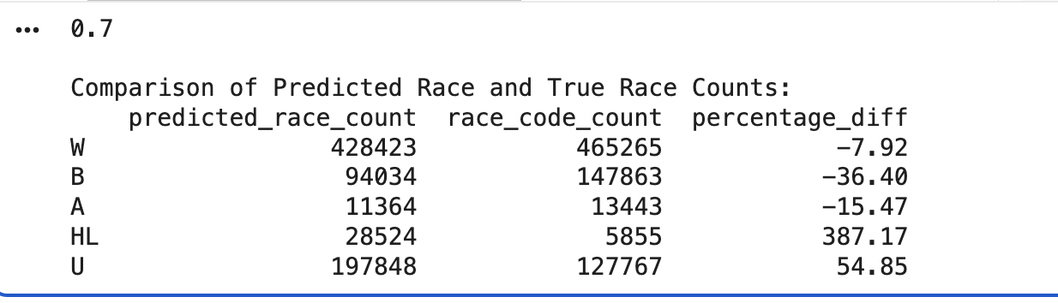

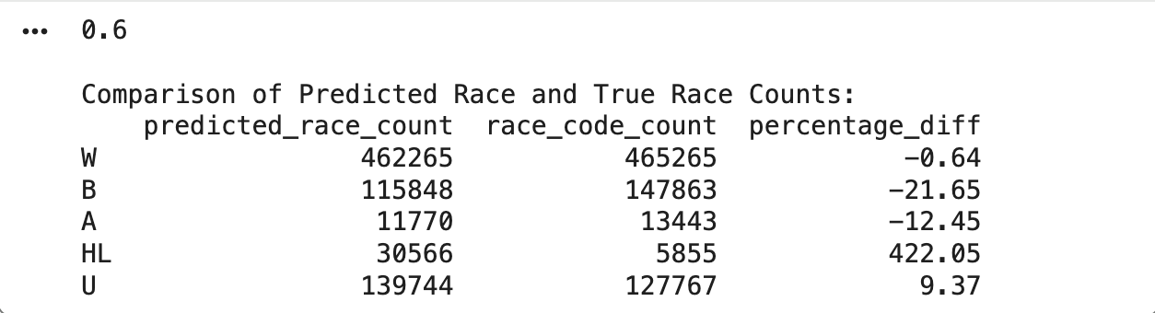

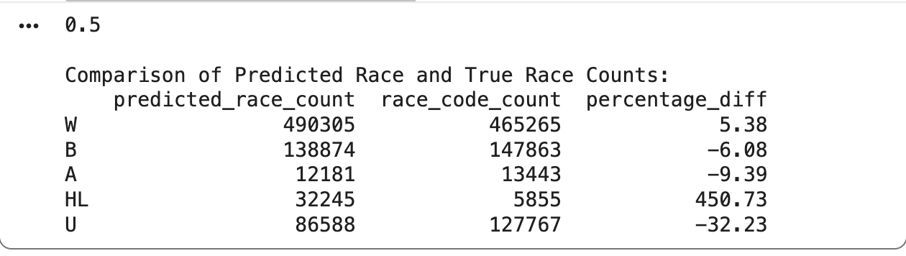

The calculation of the disparity is shown in the table <>.

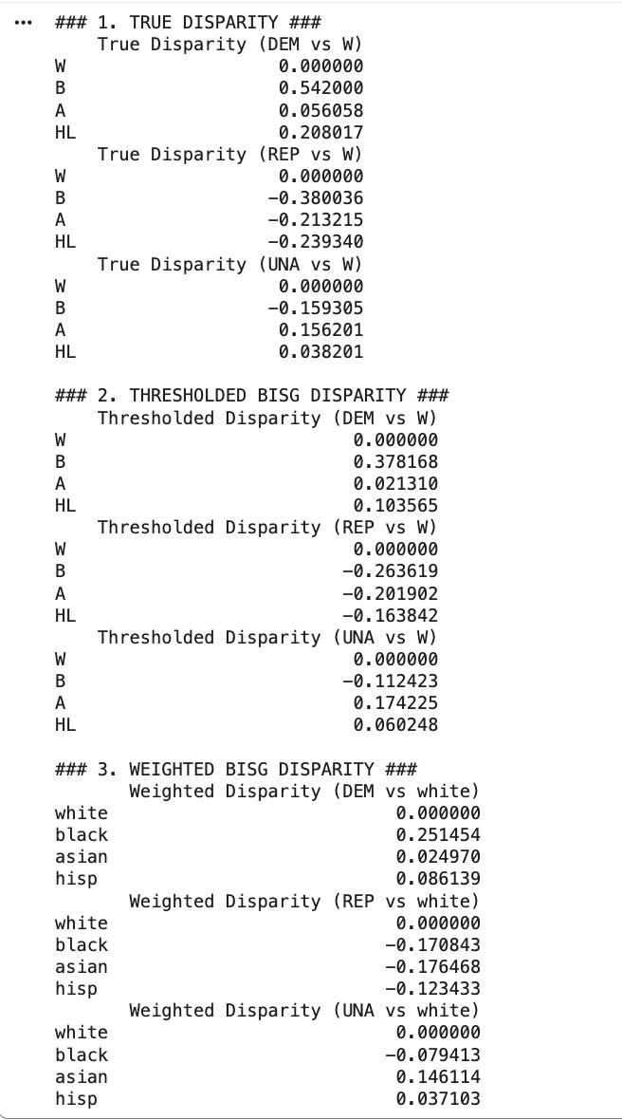

- Discussion
[What are the take-home messages from your results? Why should we care?]
Our results demonstrate that the method used to convert BISG probabilities into race labels can substantially affect measured disparities in political behavior. Although threshold-based assignment offers an easy-to-understand method of classifying people, it may lead to misclassification, particularly when probabilities are close to the cutoff. This misclassification may artificially inflate or suppress observed differences in party affiliation and distort disparity estimates, especially for smaller racial groups.

Probability-weighted (soft) BISG, on the other hand, produces more stable and complex group-level disparity measures while preserving the uncertainty present in probabilistic race estimates. This method better captures the true population-level distributions and lowers the risk of bias introduced by hard assignments, despite being more analytically complex. Our analysis shows that preserving uncertainty through weighted BISG can result in more accurate and trustworthy conclusions for applications requiring fairness assessment or policy implications.

Both strategies, though, have drawbacks. While weighted BISG increases fidelity at the expense of computational complexity and more complex analysis, thresholding is simpler to implement and interpret but may compromise accuracy. These findings highlight the importance of explicitly reporting the method used for race assignment and considering its implications for downstream analyses.

- Conclusions
[Briefly summarize what you did and why it matters. Limitations of the work often go here (or could be in Discussion). Possible directions for future work]

In this study, we evaluated two approaches for converting BISG probabilities into race labels, threshold-based and probability-weighted, and examined their effects on measuring racial disparities in political behavior. Using the North Carolina voter dataset, we found that thresholding can introduce misclassification that affects disparity estimates, whereas weighted BISG provides more robust and stable measures while retaining uncertainty.
Our findings have practical implications for researchers and policymakers who rely on imputed race data for fairness assessments and predictive modeling. Future work could explore adaptive thresholding strategies, combine BISG with additional data sources to improve accuracy, or develop methods for integrating uncertainty into standard fairness metrics. Overall, careful consideration of race assignment methodology is essential for valid and equitable analyses in social science and computational research.

References
[1] Chen, J., Kallus, N., Mao, X., Svacha, G., & Udell, M. (2019). Fairness Under Unawareness. In Proceedings of the Conference on Fairness, Accountability, and Transparency (pp. 339–348). FAT* ’19: Conference on Fairness, Accountability, and Transparency. ACM. https://doi.org/10.1145/3287560.3287594
[10] https://www.census.gov/programs-surveys/geography/guidance/geo-areas/zctas.html
[2]Kallus, N., Mao, X., & Zhou, A. (2022). Assessing algorithmic fairness with unobserved protected class using data combination. Management Science, 68(3), 1959-1981.
[3] Craig, K. J., Ji, Y. J., Zhang, Y. C., Berk, A., Zaleski, A., Abdelsamad, O., ... & Hua, G. (2024, January). Real-world application of racial and ethnic imputation and cohort balancing techniques to deliver equitable clinical trial recruitment. In AMIA Annual Symposium Proceedings (Vol. 2023, p. 319).
[4] Sartin, E. B., Metzger, K. B., Pfeiffer, M. R., Myers, R. K., & Curry, A. E. (2021). Facilitating research on racial and ethnic disparities and inequities in transportation: Application and evaluation of the Bayesian Improved Surname Geocoding (BISG) algorithm. Traffic Injury Prevention, 22(sup1). https://doi.org/10.1080/15389588.2021.1955109
[6] Greengard, P., & Gelman, A. (2025). A calibrated BISG for inferring race from surname and geolocation. Journal of the Royal Statistical Society Series A: Statistics in Society. https://doi.org/10.1093/jrsssa/qnaf003
[9] ARGYLE, L. P., & BARBER, M. (2023). Misclassification and Bias in Predictions of Individual Ethnicity from Administrative Records. American Political Science Review, 118(2), 1058–1066. https://doi.org/10.1017/s0003055423000229
[5] Adjaye‐Gbewonyo, D., Bednarczyk, R. A., Davis, R. L., & Omer, S. B. (2013). Using the Bayesian Improved Surname Geocoding Method (BISG) to Create a Working Classification of Race and Ethnicity in a Diverse Managed Care Population: A Validation Study. Health Services Research, 49(1), 268–283. https://doi.org/10.1111/1475-6773.12089
[8] Badrinarayanan, S., Osoba, O., Cheng, M., Rogers, R., Jain, S., Tandra, R., & Pillai, N. S. (2024). Privacy-Preserving Race/Ethnicity Estimation for Algorithmic Bias Measurement in the US. arXiv preprint arXiv:2409.04652.
[7] Craig, K. J., Ji, Y. J., Zhang, Y. C., Berk, A., Zaleski, A., Abdelsamad, O., ... & Hua, G. (2024, January). Real-world application of racial and ethnic imputation and cohort balancing techniques to deliver equitable clinical trial recruitment. In AMIA Annual Symposium Proceedings (Vol. 2023, p. 319).
[21] https://www.ncsbe.gov/results-data/voter-registration-data

